**TRAIN: how can a concert venue be popular and stay underground at the same time?**

by Cosmin Coman | 10.10.2018 | *Music Scene*

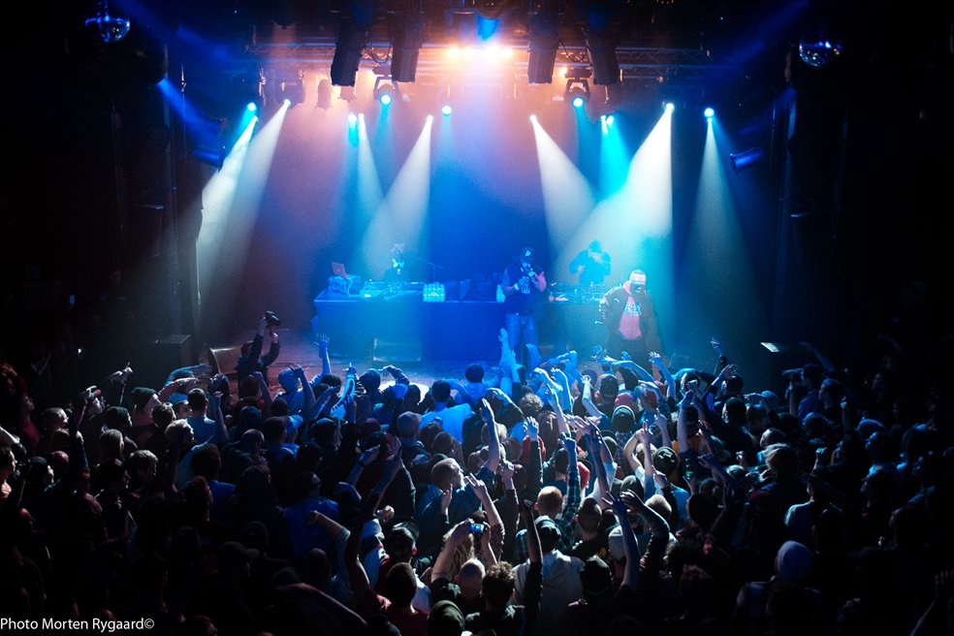

Redman & Method Man concert @ Train. Source: http://www.djoybeat.com

*Are you a Snoop Dog fan? Do you consider yourself more of a Whitesnake listener? Have you ever dreamt of seeing Joe Satriani in a live concert? Or maybe you’re more into underground events, feeling more comfortable in small audience crowds.*

*Then you should definitely check out the place made for any of these kinds of concert goers. It’s called* ***Train*** *and it’s located in Aarhus.*

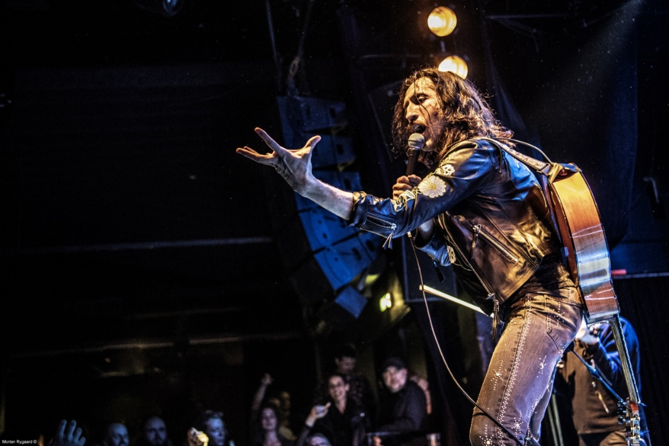

Gogol Bordelo @ Train. Source: <http://www.train.dk>

**Why Train?**

After buying that vintage jacket (link), you must be looking for a cool concert where you can wear it. However, it seems that nowadays it’s harder than ever to find a good place to listen to some good ol’ live rock music.

[Train](http://www.train.dk/) started in 1998 as a place where people of Aarhus can attend rock concerts. What started as a private initiative as a contribution to the local music scene has since grown into one of the most popular venues in the country.

In 2000 Train was appointed as the Regional Venue and Cultural Growth Center of Aarhus Municipality and the Danish Arts Council.

Train has been one of Denmark's largest concert venues, carrying a high quality and international class music profile. This is a place where you can see world names presented side by side with artists of a more narrow and niche character.

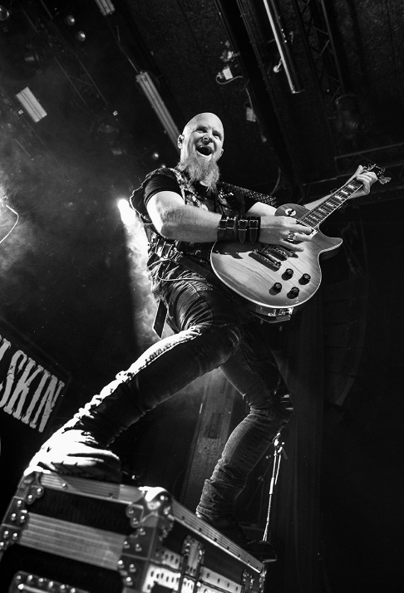

Halestorm @ Train. Source: <http://www.train.dk>

A picture containing indoor, man, red

Description generated with high confidence

Morten @ Train. Source: <http://www.train.dk>

A person standing on a stage

Description generated with high confidence

Desiigner @ Train. Source: <http://www.train.dk>

If you want to find out more about Train’s profile, you can check out their nice presentation [here](https://www.train.dk/sites/train.dk/files/train.profil.pdf).

**Hall of Fame**

Billy Idol, Kashmir, The Cult, Wolfmother, Napalm Death.

Along the time, a bunch of pretty remarkable names held concerts here. The list is quite long and can be seen in its entirety [here](http://www.train.dk/hall-fame).

**Facts on Train:**

* The capacity of Train at Live Concerts is 1,000 standing / 270 seated audiences. At events the capacity is 1300.
* TRAIN is run by the TRAIN Fund. The fund is non-profit and cultural entrepreneur with the goal to support the music and the rhythmic environment in Aarhus, the region and the country.

**Our tip:**

Try to keep an eye with their [Facebook page](https://www.facebook.com/Train.live) and use [Bands in Town](https://www.bandsintown.com/en) so you can be amongst the first ones to find about upcoming concerts.